Inventory Management System / IMS

# User Manual - Website

Version 1.5

12/20/2018

Table of Contents

1. Introduction 1

2. Overview 2

2.1 Conventions 2

2.2 Cautions & Warnings 2

3. Getting Started 3

3.1 Set-up Considerations 3

3.2 User Access Considerations 3

3.3 Accessing the System 3

3.4 System Organization & Navigation 4

3.5 Exiting the System 5

4. Using the System 6

4.1 Dashboard 6

4.2 Administration 7

4.2.1 User Details 7

4.2.2 Change Role 7

4.3 Maintenance 8

4.3.1 Shipper 9

4.3.2 Supplier 9

4.3.3 Customer 9

4.3.4 Product 10

4.4 Order 10

4.4.1 Create New Order 11

4.4.2 Order Details 12

4.4.3 Add Products 13

4.4.4 Ship Order 13

4.5 Natural Language Search (NLS) 14

Appendix A: Record of Changes 15

Appendix B: Glossary 16

Appendix C: Referenced Documents 17

List of Tables

Table 1 - Record of Changes 15

Table 2 - Glossary 16

Table 3 - Referenced Documents 17

## Introduction

IMS is an online system that satisfies the requirement of a generalized Inventory and Stock Maintenance system. It provides a user interface to perform daily transactions and generate analytical reports for the management. The purpose of this document is to provide a guide to using the system and perform the operations in the correct sequence, the document is intended for beginners of the system and act as a reference of the business flow. This document is intended to be used by Business team as changes to this document would be performed when the actual application has been changed.

This User Manual (UM) provides the information necessary for business users, cashiers to effectively use the Inventory Management System (IMS).

## Overview

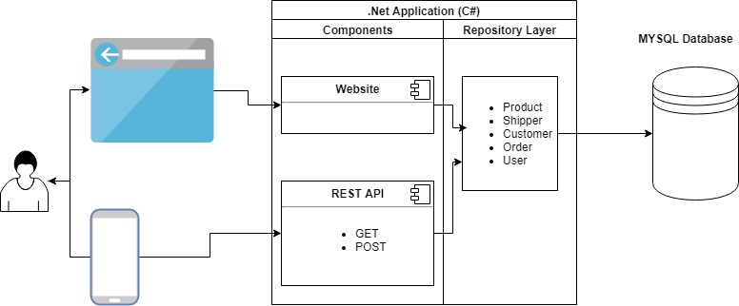

* The application will track stock and inventory maintenance.
* Web based system along with a companion mobile application that allows for quick data look up
* Graphical User Interface with role-based access to sections of the application

### Conventions

This document provides screen prints and corresponding narrative to describe how to use the IMS.

When an action is required on the part of the reader, it is indicated by a line beginning with the word “Action:” For example:

Action: Click on OK.

Fields or buttons to be acted upon are indicated in bold italics in the Action statement; links to be acted upon are indicated as links in underlined blue text in the Action statement.

Note: The term ‘user’ is used throughout this document to refer to a person who requires and/or has acquired access to the <System Name and/or Acronym>.

### Cautions & Warnings

Do not maintain separate copies of this document on your machine. This document will be regularly updated, and it would be best served to be looked up from the repository.

## Getting Started

### Set-up Considerations

IMS website will work on most modern browsers with a screen resolution of 1280 * 720 or higher. To optimize your access to the IMS:

1. Please disable pop-up blockers prior to attempting access

### User Access Considerations

Instructions: Describe the different users and/or user groups and the restrictions placed on system accessibility or use for each.

The system consists of 3 user roles: Administrator, Manager and Cashier

**Administrator**: has access to all the administration, maintenance and order sections. User with administrator preferences can only modify user access to the website and mobile application.

**Manager**: has access to maintenance and order sections

**Cashier**: has access to the order section

### Accessing the System

**User Login:** Users with existing user id can access the website and login

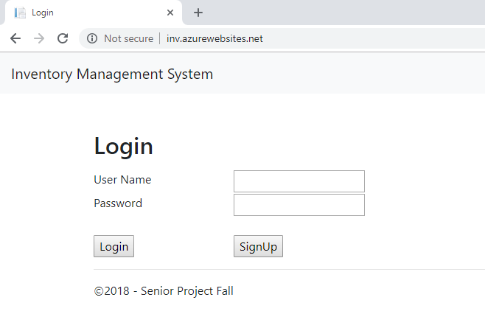

**Sign Up:** New users can sign up by entering personal information and login information

**Action:** Click on signup on the login page and that will redirect to the user registration page

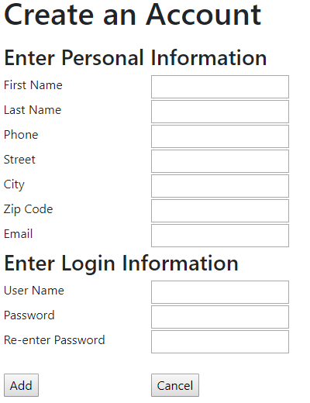

**Action:** Click “Add” upon successful validation a new user account is created.

**Note:** Default user role is cashier and the user will need to request an administrator to modify permission.

### System Organization & Navigation

The landing page of the application is the Dashboard. The main navigation panel located on the left side is left intact and lets the user navigate through the website.

The top navigation bar consists of items needed for quick access and minimal navigation

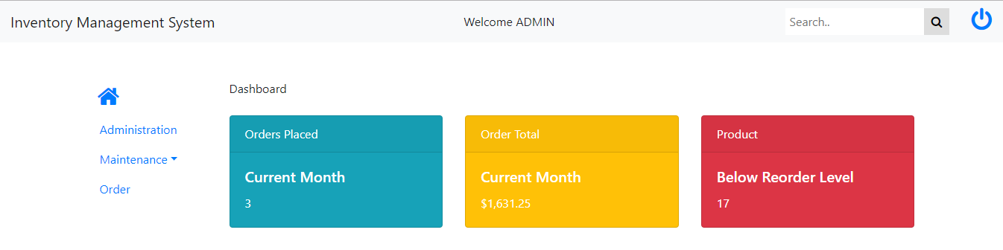

### Exiting the System

User can close the browser or logout the system.

**Action:** Click on “Logout” icon on top navigation bar

## Using the System

The following sub-sections provide detailed, step-by-step instructions on how to use the various functions or features of the IMS.

### Dashboard

The dashboard is the landing page of the application, it displays an executive summary of the inventory system.

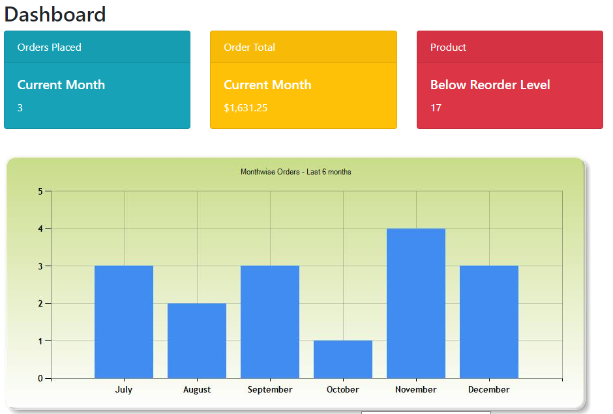

### Administration

The administration section is accessed from the “Administration” menu on the main navigation. The administration section is accessible by users belonging to the “Administrator” role. This section allows the user to modify user details and change access roles.

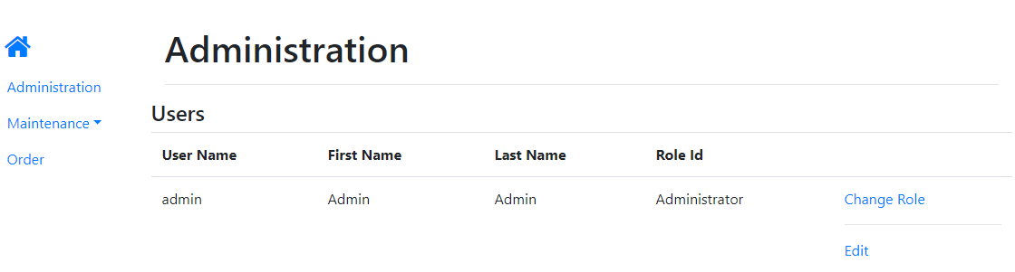

**Action:** “Change Role” – navigates the user to a screen that allows to quickly modify access

“Edit” – Redirects the user to the user details screen

#### User Details

From the below screen an administrator can modify personal information or delete this account.

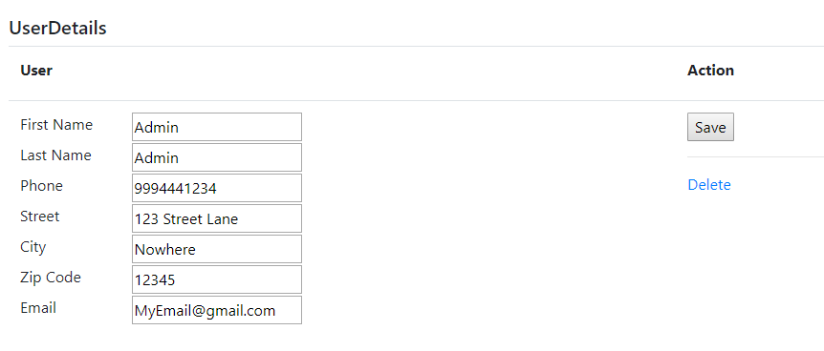

**Action:** “Delete” – will delete the current selected user

“Save” – updates personal information

#### Change Role

From the below screen an administrator can modify the role of this account.

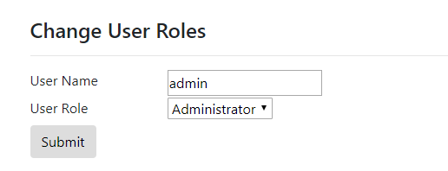

**Action:** “Submit” – updates role of current selected user

### Maintenance

The maintenance section is accessed from the “Maintenance” menu on the main navigation. It consists of 4 submenus which are 4 different sections which support maintenance.

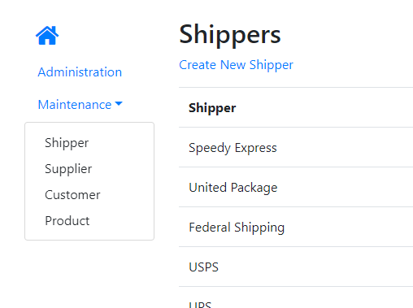

#### Shipper

From the below screen the user can create a new shipper and modify an existing shipper.

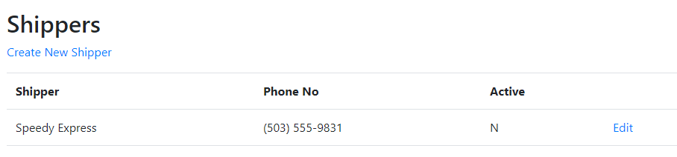

**Action:** “Create New Shipper” – redirects to a screen that allows creation of shipper

“Edit” – redirects to a screen that allows editing the selected shipper

#### Supplier

From the below screen the user can create modify an existing supplier.

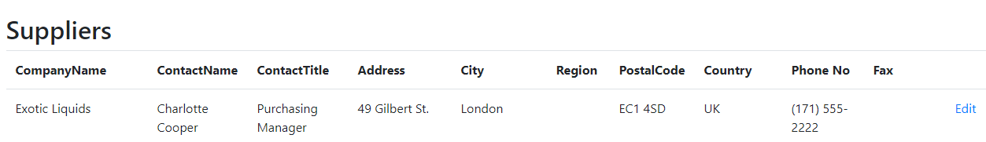

**Action:** “Edit” – redirects to a screen that allows editing the selected supplier

#### Customer

From the below screen the user can create modify an existing customer.

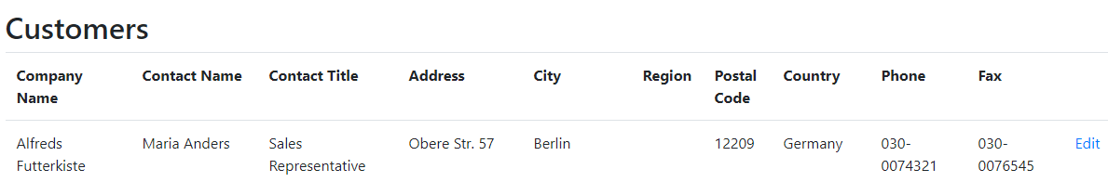

**Action:** “Edit” – redirects to a screen that allows editing the selected customer

#### Product

From the below screen the user can create modify an existing customer.

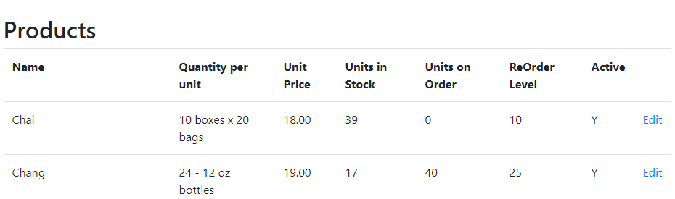

**Action:** “Edit” – redirects to a screen that allows editing the selected product

### Order

The ordering system is accessed from the “Order” menu on the main navigation. The ordering process is divided into 3 pieces: creating an order, adding products to an order, shipping the order using a shipper.

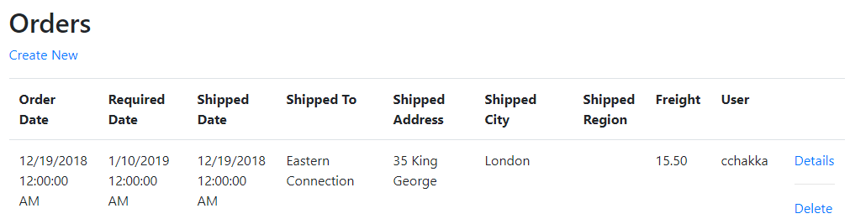

**Action:** “Create New Order” – redirects the user to a screen that allows creating a new order

“Details” - redirects the user to a screen that allows to ship an order

“Delete” - after asking for a confirmation deletes the order

#### Create New Order

From the below screen the user can create a new order.

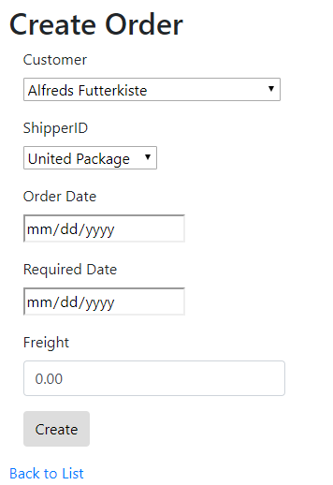

**Action:** “Create” – creates the order and redirects to the “Details” screen

#### Order Details

The order details screen allows the user to ship an order or add products to the order. The order details can be opened from the orders screen and this screen opens once the user created an order successfully.

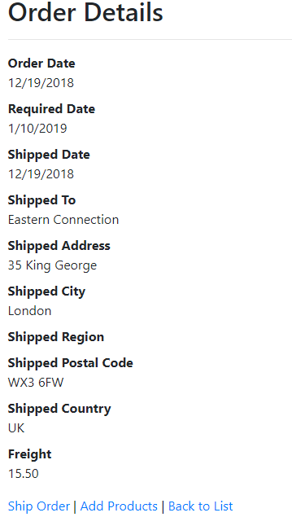

**Action:** “Ship Order” – once the products are added and the shipper arrives to pick the order

“Add Products” – adds products to an order

#### Add Products

The products screen lets you delete an existing product from order or add a new product.

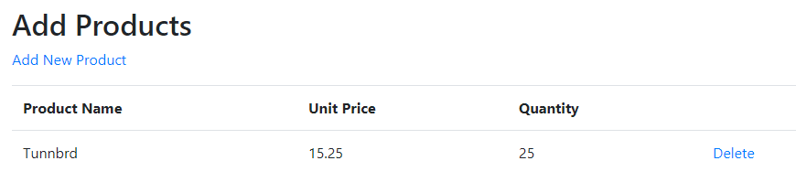

**Action:** “Add New Product” – redirects user to add a new product

“Delete” – upon user confirmation deletes a product item

#### Ship Order

This screen lets you update the shipped date on the order.

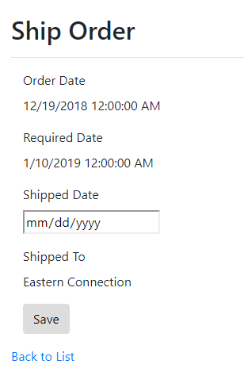

**Action:** “Save” – updates shipping date

### Natural Language Search (NLS)

The NLS is an implementation using Microsoft’s LUIS (Language Understanding Intelligent Service) the purpose of using NLS is to avoid creating complicated search screens with multiple fields which are hard to modify.

The quick search on the top navigation bar is the entry point of NLS.



After performing a search, the intent response from LUIS, along with the SQL Query created using that is displayed.

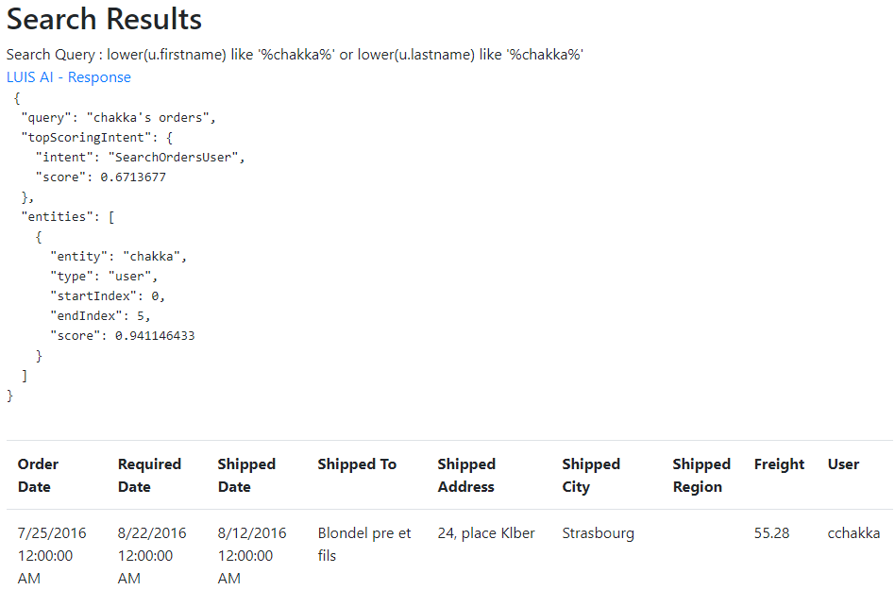

Appendix A: Record of Changes

Table 1 - Record of Changes

| Version Number | Date | Author/Owner | Description of Change |
| --- | --- | --- | --- |
| 1.0 | 12/15/2018 | Nick Turner | Creating the template and adding the table of contents with empty sections |
| 1.1 | 12/16/2018 | Mohib Ahmed | Adding introduction and overview |
| 1.2 | 12/16/2018 | Kyle Parker | Getting started section along with screen shots for login and registration |
| 1.3 | 12/17/2018 | Quentin Terry | Section on Administration, Maintenance |
| 1.4 | 12/18/2018 | Erik W. | Section on Order, Dashboard |
| 1.5 | 12/18/2018 | Chaitanya C. | Section on NLS |

Appendix B: Glossary

Table 2 - Glossary

| Term | Acronym | Definition |
| --- | --- | --- |
| Inventory Management System | IMS | Commonly reference the application as IMS instead of the full term. |
| Natural Language Search | NLS | Parsing user search criteria in regular language to system understandable query. |

Appendix C: Referenced Documents

Table 3 - Referenced Documents

| Document Name | Document Location and/or URL |
| --- | --- |
| Detailed Spec | https://github.com/chaitanyakumar/SeniorProjectFall2018/tree/master/Documents |
| Software Design Document | https://github.com/chaitanyakumar/SeniorProjectFall2018/tree/master/Documents |